User Manual Guide
Education Resources Allocation And Distribution System (DERAS)
University of Computer Studies, Hinthada (UCSH)

Introduction
This user guide explains how to use the Education Resources Allocation and Distribution System (DERAS). The system helps authorized staff plan, allocate, and record the distribution of textbooks, teacher guides and handbooks, and school supplies across townships. After login, Admin users can carry out daily allocation work, while Super Admin users can also manage accounts, delete selected records, and perform academic-year rollover. The following sections describe how to open the system, sign in, and complete the main tasks in the correct working order.

Getting Started
Accessing the System:
- Open the system URL in a browser (local Laragon example: http://deras.test or http://localhost/DERAS/public).
- The Login page appears.
- Enter the email and password provided by the administrator.
- After successful login, the Dashboard opens with the left sidebar menu.
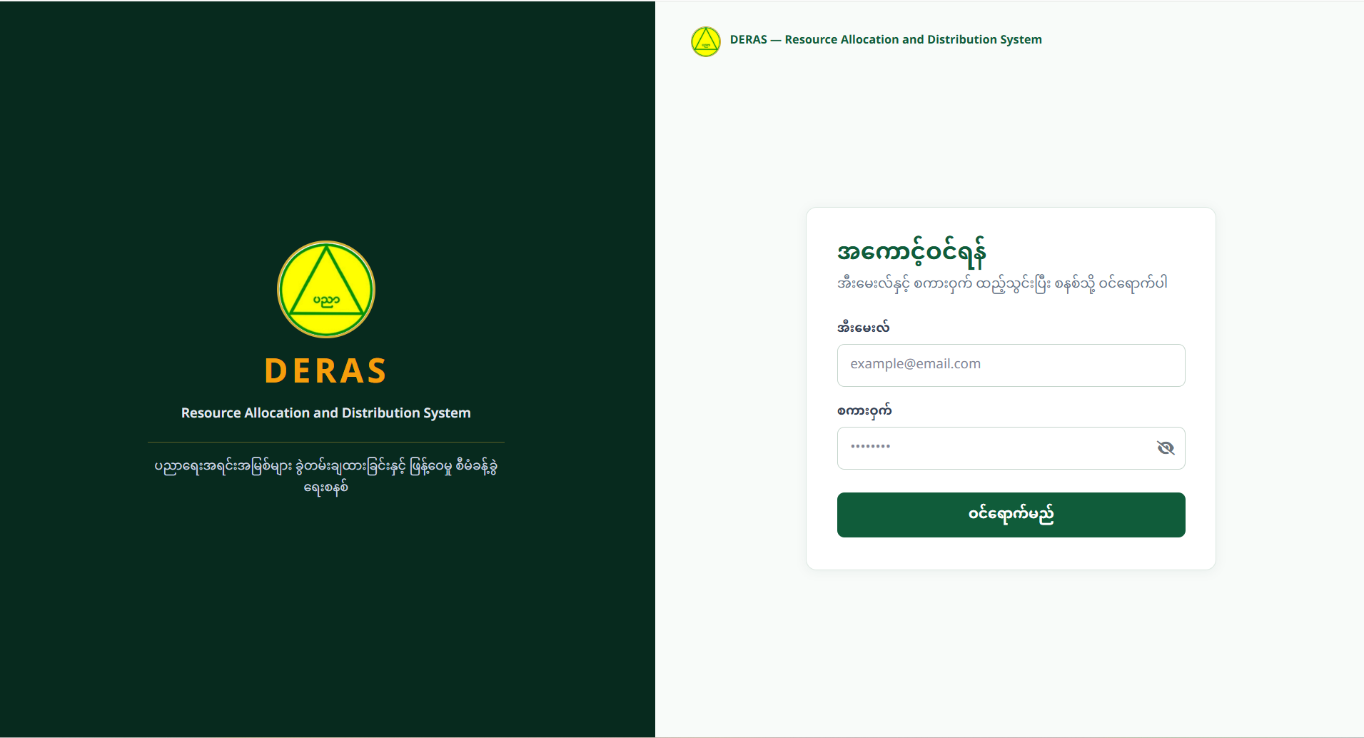
Figure 1: Login Page of System

